Latest Round-ups:
Season 2019/20
#29
Midweek Action: Street forward Leighton Thomas was the standout performer on a busy Tuesday evening, scoring a hat trick during his side’s 4-0 victory over Clevedon in the Premier Division. Thomas is in excellent goalscoring form of late, and after scoring twice in the first half, he struck again at the end of the game to complete a one-sided victory for the Cobblers.
In the First Division, Ashton & Backwell claimed a dramatic late winner in their top-five clash away at Longwell Green Sports. The visitor’s went ahead at Shellards Road through Calum Townsend, who fired home from the spot after 16 minutes. Longwell Green then grabbed an equaliser, before both sides were reduced to ten men following different incidents at the beginning of the second half. With the game moving into stoppage time, Ashton put themselves firmly in the promotion race, with George Jones finding the back of the net to extend their unbeaten run to ten matches. Wincanton Town also picked up three points on Tuesday, with a 5-2 victory at home to Corsham helping them arrest a two-game losing streak. The home side were rampant during the first half, and found themselves three goals to the good thanks to efforts from Dan Wise, Gary Chapman and Connor Williams. Corsham pulled a goal back just before the interval through Ben Wickens, and then in the opening minute of the second half, Ash Alchin fired home to reduce the deficit to just one as they eyed a famous comeback. Wincanton finally put the game to bed midway through the second half when Toby Cole and Williams struck in quick succession to register their 11th league victory this term.
There was also a trio of quarterfinals in the Gloucestershire FA Challenge Trophy that night, with plenty of Western League sides in action. One of these teams were Lebeq United, and they enjoyed late success away at Cribbs Reserves, with a last-minute winner seeing them qualify for the semi-final round. The Bristol-outfit will be joined by Oldland Abbotonians who struck twice in the closing stages to register an impressive 3-1 victory away at Hallen. The home side have been in stellar league form, but required a beautiful free kick from Ben Willshire to grab a share of the half-time spoils after an own-goal had handed the Abbots a 36th minute lead. With ten minutes left on the clock, Joe Beardwell was upended in the Hallen box at the end of a surging run, and he dusted himself down before applying a strong finish from the penalty spot to restore Oldland’s lead. In stoppage time, Hallen sent their keeper up for a late corner, but the ball broke clear for Owen McCallum who slipped the ball into an empty net from outside the area to complete the win. In the other tie, Bitton followed up their victory in the FA Vase with another 2-1 triumph, this time at home to Wick thanks to goals from Karim Rendall and Oaklan Buck. A late red card to keeper Rob Brown was followed soon after by an injury-time goal for the visitors, but Bitton held out with ten men to reach the semi-final stage. 24 hours later, Roman Glass St George completed a clean sweep for Western League sides, beating Gala Wilton on 5-3 on penalties after the match finished 1-1 at the end of 90 minutes. The Glass will take on Oldland in the last four next month, with Bitton hosting Lebeq in the other semi-final.
Hengrove Athletic created a little bit of history in the Somerset Premier Cup on Tuesday. Having had a tough 2019, Hengrove have enjoyed a much better run of results to start the new decade and that continued in their resounding quarterfinal victory over Cheddar. Youngster Jack Jones struck all three of the Grove’s goals during their 3-0 win to book their spot in the final four for the first time in the club’s history.
It was a big night in the Premier Division on Wednesday, with four of the top six in action. The big clash at the top had late drama, with Bradford nicking all three points at home to Shepton Mallet thanks to an 88th minute winner. The game lived up to the hype in the opening stages, with Tyson Pollard heading Bradford in front, before Aaron Seviour equalised a couple of moments later to make it 1-1 inside ten minutes. Attempts on goal dried up a little bit after that, but then with just two minutes left on the clock, Charlie Maddison unleashed a rasping drive which nestled in the back of the net to secure a crucial victory for the league leaders. The remaining matches that night saw a pair of one-sided wins for a duo of promotion-chasing Devon sides. At Springfield, Tavistock put seven past Cadbury Heath in a resounding victory, with leading scorer Jack Crago notching another brace. Liam Prynn was also on target in either half, with further goals from the visitors coming from Callum Watson, Tallan Burns and Warren Daw. Exmouth Town joined Tavistock in reaching the 50-point mark following their 5-0 triumph at home to Cribbs. The game was as good as over after half an hour, with Jamie Dirrane and Max Gillard joining the in-form Jordan Harris on the scoresheet. Exmouth went into the fixture on the back of a four-match winless run, but that was well and truly forgotten, with Harris on target twice more during the second half to complete his hat-trick at the King George V Ground.
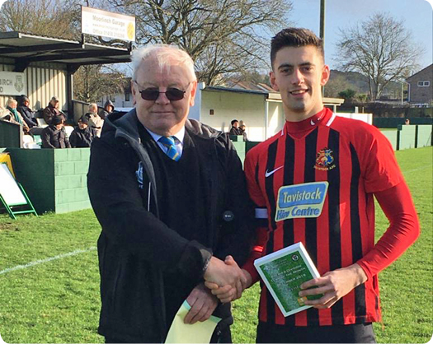
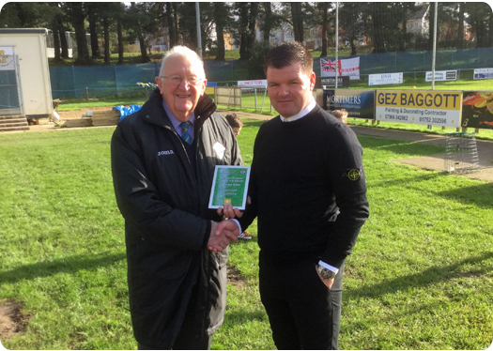
FA Vase Quarter Final Draw
Having enjoyed home fixtures in the previous round, both Bitton and Plymouth Parkway will be on their travels in the last eight of the Vase. Bitton will head to Norfolk to take on Wroxham of the Eastern Counties League side. Plymouth Parkway will have to travel slightly further afield, with a 400-mile trip to the North-East where they will challenge Northern League outfit Hebburn Town. The quarter final ties will take place on Saturday 29th February.

Brian Beer and Richard Palette present the Premier Division Team of the Month awards to Plymouth Parkway (left) and Tavistock (right) for January and December respectively.
Becks in Clevedon!
David Beckham spent his Wednesday evening at the Hand Stadium, watching his Romeo play for Millfield School against the Clevedon Town under-18 team.

Weekend Action: Only one game managed to beat Storm Dennis on Saturday afternoon, but it certainly didn’t lack for drama with Keynsham and Bitton each scoring late on during their 1-1 draw. With 235 hardy souls battling the conditions, they certainly saw a terrific finish to the game at the Crown Fields, where Bitton believed they had taken all three points following a lovely finish from outside the box by Matt Groves five minutes from time. Keynsham weren’t to be denied however, and they grabbed a draw in stoppage time when Mike Grist headed home a corner.

Latest Results
Tuesday 11th February 2020
Premier Division
Street 4-0 Clevedon Town 57
First Division
Longwell Green Sports 1-2 Ashton & Backwell United 90
Wincanton Town 5-2 Corsham Town 33
GFA Challenge Trophy – Quarter Final Round
Bitton 2-1 Wick 106
Cribbs Reserves 1-2 Lebeq United
Hallen 1-3 Oldland Abbotonians 47
Somerset FA Premier Cup – Quarter Final Round
Hengrove Athletic 3-0 Cheddar
Wednesday 12th February 2020
Premier Division
Bradford Town 2-1 Shepton Mallet 111
Cadbury Heath 2-7 Tavistock 40
Exmouth Town 5-0 Cribbs 102
GFA Challenge Trophy – Quarter Final Round
Roman Glass St George 1-1 (5-3 pens) Gala Wilton 35
Saturday 15th February 2020
Premier Division
Keynsham Town 1-1 Bitton 235
Western League Statistical Leaders

PREMIER DIVISION LEADING GOAL SCORERS (League only):
Adam Carter (Plymouth Parkway) – 27
Jordan Harris (Exmouth Town) – 22
Jack Fillingham (Shepton Mallet) – 20
Leighton Thomas (Street) – 18
Mikey Williams (Plymouth Parkway) – 16
Jack Taylor (Bridgwater Town) – 16

PREMIER DIVISION TOP ATTENDANCES:
Plymouth Parkway 2 Tavistock 3, Thursday 26th December 2019 - 564
Bridport 0 Bridgwater Town 6, Sunday 6th October 2019 – 347
Wellington 0 Exmouth Town 2, Sunday 6th October 2019 - 315

FIRST DIVISION LEADING GOAL SCORERS (League only):
Harry Foster (Wells City) – 23
James Rustell (Radstock Town) – 19
Stuart Windsor (Calne Town) – 17
Alex Murphy (Sherborne Town) – 14
Josh Bright (Corsham Town) – 13
Toby Cole (Wincanton Town) – 12

FIRST DIVISION TOP ATTENDANCES:
Warminster Town 2 Bristol Telephones 3, Saturday 5th October 2019 - 369
Longwell Green Sports 1 Oldland Abbotonians 2, Saturday 28th December 2019 - 289
Portishead Town 3 Longwell Green Sports 5, Saturday 5th October 2019 – 262

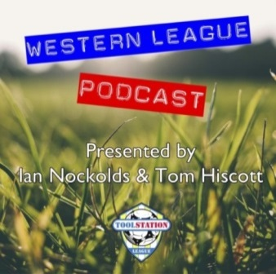
LEADING SCORERS IN ALL COMPETITIONS:
Jack Crago (Tavistock) - 35
Harry Foster (Wells City) – 30
Adam Carter (Plymouth Parkway) – 27
Jack Fillingham (Shepton Mallet) – 25
Jordan Harris (Exmouth Town) - 25
James Rustell (Radstock Town) – 24
Jack Taylor (Bridgwater Town) – 23
Be sure to check out the latest podcast, where Ian, Tom & guests recap all the latest news and results from around the Western League. To follow along all season, each broadcast will be available at the following link: http://www.toolstationleague.com/podcasts.php
*All goalscoring stats
via Full-Time FA website

Upcoming Fixtures
Tuesday 18th February 2020
Premier Division
Bitton vs Shepton Mallet 19:30KO
Brislington vs Keynsham Town 19:30KO
Odd Down vs Exmouth Town 19:45KO
First Division
Almondsbury vs Wells City 19:30KO
Bishop Sutton vs Wincanton Town 19:30KO
Les Phillips Cup – Quarter Final
Hallen vs Cheddar 19:45KO
Wiltshire FA Senior Cup – Semi Final
Corsham Town vs Bemerton Heath Harlequins 19:45KO
Somerset FA Premier Cup – Quarter Final
Welton Rovers vs Yeovil Town 19:45KO
Wednesday 19th February 2020
Premier Division
Cadbury Heath vs Buckland Athletic 19:30KO
Clevedon Town vs Plymouth Parkway 19:45KO
First Division
Bishops Lydeard vs Devizes Town 19:30KO
Radstock Town vs Bristol Telephones 19:30KO
Les Phillips Cup – Quarter Final
Roman Glass St George vs Bradford Town 19:30KO
Tavistock vs Warminster Town 19:30KO
Wiltshire FA Senior Cup – Semi Final
Calne Town vs Wroughton 19:45KO
Saturday 22nd February 2020 (KICK OFF AT 3.00PM UNLESS NOTED)
Premier Division
Bradford Town vs Tavistock
Bridgwater Town vs Hallen
Bridport vs Bitton
Cadbury Heath vs Plymouth Parkway
Chipping Sodbury Town vs Clevedon Town
Cribbs vs Shepton Mallet
Exmouth Town vs Wellington
Odd Down vs Buckland Athletic
Roman Glass St George vs Street
Westbury United vs Brislington
First Division
Ashton & Backwell United vs Cheddar
Bristol Telephones vs Bishops Lydeard
Calne Town vs Wincanton Town
Corsham Town vs Sherborne Town
Devizes Town vs Portishead Town
Hengrove Athletic vs Almondsbury
Longwell Green Sports vs Bishop Sutton
Radstock Town vs Oldland Abbotonians
Wells City vs Lebeq United
Welton Rovers vs Warminster Town

League Tables
Premier Division
 |  | P | W | D | L | F | A | GD | PTS
1 | Bradford Town | 22 | 19 | 1 | 2 | 69 | 20 | 49 | 58
2 | Plymouth Parkway | 20 | 17 | 1 | 2 | 71 | 19 | 52 | 52
3 | Hallen | 25 | 16 | 4 | 5 | 56 | 38 | 18 | 52
4 | Tavistock | 22 | 16 | 2 | 4 | 61 | 27 | 34 | 50
5 | Exmouth Town | 22 | 16 | 2 | 4 | 55 | 21 | 34 | 50
6 | Shepton Mallet | 24 | 15 | 3 | 6 | 60 | 30 | 30 | 48
7 | Bridgwater Town | 25 | 13 | 6 | 6 | 63 | 37 | 26 | 45
8 | Bitton | 22 | 13 | 2 | 7 | 58 | 33 | 25 | 41
9 | Street | 28 | 12 | 4 | 12 | 60 | 60 | 0 | 40
10 | Clevedon Town | 26 | 12 | 4 | 10 | 53 | 54 | -1 | 40
11 | Westbury United | 26 | 11 | 3 | 12 | 49 | 38 | 11 | 36
12 | Keynsham Town | 27 | 10 | 4 | 13 | 47 | 54 | -7 | 34
13 | Buckland Athletic | 21 | 10 | 2 | 9 | 38 | 42 | -4 | 32
14 | Brislington | 24 | 9 | 4 | 11 | 35 | 55 | -20 | 31
15 | Roman Glass St George | 24 | 8 | 4 | 12 | 52 | 41 | 11 | 28
16 | Cadbury Heath | 28 | 6 | 7 | 15 | 33 | 71 | -38 | 25
17 | Cribbs | 25 | 7 | 2 | 16 | 33 | 63 | -30 | 23
18 | Bridport | 25 | 5 | 2 | 18 | 35 | 80 | -45 | 17
19 | Chipping Sodbury Town | 26 | 5 | 1 | 20 | 29 | 84 | -55 | 16
20 | Wellington | 27 | 3 | 3 | 21 | 24 | 67 | -43 | 12
21 | Odd Down | 25 | 3 | 1 | 21 | 22 | 69 | -47 | 10

First Division
 |  | P | W | D | L | F | A | GD | PTS
1 | Calne Town | 24 | 16 | 2 | 6 | 42 | 18 | 24 | 50
2 | Sherborne Town | 24 | 16 | 2 | 6 | 56 | 33 | 23 | 50
3 | Wells City | 24 | 14 | 6 | 4 | 64 | 27 | 37 | 48
4 | Longwell Green Sports | 25 | 15 | 3 | 7 | 59 | 37 | 22 | 48
5 | Ashton & Backwell United | 24 | 14 | 6 | 4 | 40 | 37 | 3 | 48
6 | Radstock Town | 20 | 14 | 1 | 5 | 49 | 26 | 23 | 43
7 | Corsham Town | 25 | 12 | 3 | 10 | 43 | 50 | -7 | 39
8 | Wincanton Town | 20 | 11 | 2 | 7 | 41 | 42 | -1 | 35
9 | Oldland Abbotonians | 21 | 10 | 5 | 6 | 29 | 32 | -3 | 35
10 | Cheddar | 22 | 10 | 4 | 8 | 38 | 34 | 4 | 34
11 | Bishops Lydeard | 22 | 10 | 3 | 9 | 48 | 35 | 13 | 33
12 | Lebeq United | 23 | 10 | 0 | 13 | 47 | 54 | -7 | 30
13 | Hengrove Athletic | 24 | 8 | 4 | 12 | 21 | 46 | -25 | 28
14 | Warminster Town | 23 | 8 | 2 | 13 | 41 | 38 | 3 | 26
15 | Portishead Town | 23 | 7 | 4 | 12 | 40 | 43 | -3 | 25
16 | Almondsbury | 22 | 7 | 4 | 11 | 31 | 37 | -6 | 25
17 | Welton Rovers | 24 | 6 | 4 | 14 | 27 | 44 | -17 | 22
18 | Devizes Town | 23 | 3 | 6 | 14 | 33 | 54 | -21 | 15
19 | Bishop Sutton | 23 | 3 | 3 | 17 | 25 | 52 | -27 | 12
20 | Bristol Telephones | 22 | 2 | 2 | 18 | 28 | 63 | -35 | 8

